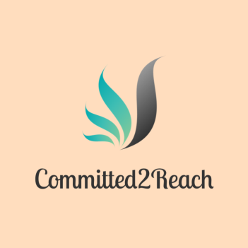
COMMITTED 2 REACH
MEMBERSHIP APPLICATION

Name: __________________________________________________________________________
Address : __________________________________________________________________________
Mailing Address (if different): _______________________________________________________________
Phone: _____________________Email: __________________________________________
Are you renewing your membership? If yes, date of membership expiration_________ No _____________
Renewal Fee is $15 for all membership types unless membership has lapsed for 6 months, then applicant must pay regular new member fees.
Type of Membership:
______Voting Member ($75.00) must renew every 2 years: Involved in all director voting meetings, allowed into all community events, t-shirt cost included, 2 family members allowed into each event at no charge. Additional dues required with this type of membership.
______ Active Member ($50.00) must renew every 1 year: Involved in fundraising, recruiting, and other regular duties as outlined in membership requirements. Free admission to all community events, Non-Profit t-shirt included, and required to attend all event planning meetings. Additional dues are required with this type of membership.
______Associate Member ($25.00) must renew every 1 year: Fundraising and support for community events. Free admission to all community events, T-shirt cost not included.
Tell us a little about yourself and what motivates you to join our organization: ____________________________________________________________________________________________________________________________________________________________________________________________________________________________________________________________________________________________________________________________________Visit our Webpage www.committed2reach.org
Contact us: Committed2Reach@gmail.com or (804) 475-4649 for additional information

Additional Membership Requirements:
All Quarterly Dues are paid during the 1st through the 7th in the months March, July and November
Voting Member: Quarterly Dues $15
- Membership must be renewed every 2 years
  - Renewal based on participation at events, meeting fundraising goals, meeting attendance
- Required to attend at least 2 meetings each month (no more than 4 meetings will be held)
- Required to provide 120 hours of service each year (planning meetings for events, set up, break down, fundraising time, donation drives etc.)
- Required to raise $3000 each year
  - May include tips made at events, personal money raised, friends/family donations etc.
- Allowed free admission to all community events along with 2 complimentary passes for family/friends
- Committed 2 Reach T-shirt provided once approved as voting member
ACTIVE MEMBER: Quarterly Dues $10
- Membership must be renewed every 1 year
  - Renewal based on meeting fundraising goals, participation at events
- Required to attend 1 event planning meeting per month (no more than 2 each month)
- Required to provide 120 hours of service each year (planning meetings for events, set up, break down, fundraising time, donation drives etc.)
- Required to raise $1500 each year
  - May include tips made at events, personal money raised, friends/family donations etc.
- Allowed free admission to all community events
- Committed 2 Reach T-shirt provided after application approval
ASSOCIATE MEMBER: Quarterly Dues $5
- Membership must be renewed every 1 year
  - Renewal based on meeting fundraising goals, participation at events
- Required to provide 120 hours of service each year (planning meetings for events, set up, break down, fundraising time, donation drives etc.)
- Required to raise $500 each year
  - May include tips made at events, personal money raised, friends/family donations etc.
- Free admission to community events

Visit our Webpage www.committed2reach.org
Contact us: Committed2Reach@gmail.com or (804) 475-4649 for additional information

